**Voice Assistant for Visually Impaired**

**Abstract:**

*In today’s advanced hi-tech world, the need of independent living is recognized in case of visually impaired people who are facing main problem of social restrictiveness. Due to lack of necessary information in the surrounding environment, visually impaired people face problems and are at disadvantage since visual information is what they lack the most. With the help of the advanced technology, the visually impaired can be supported in detecting the objects they come in contact with along with their respective distance from the user. As a solution to the problem mentioned, we are using Machine Learning and IoT sensor which can be helpful to the visually impaired as they can predict the distance of the object that they can come to contact with satisfactory approximation by training our machine with real time data. The visually impaired will be assisted through English voice commands generated by the application according to the obstacle position.*

**Introduction:**

Billions of people around the entire face the visibility problem and this is a black dot. With the help of Artificial Intelligence and Machine Learning we have aimed at removing this black dot. The severe consequences that visual impairment presents on certain capabilities related to visual function:

1. Day to day activities(require
2. s average distance vision)
3. Estimating area and displacement(requires far vision)

The proposed system is used for the visually impaired to detects the objects that are close to him/her and returns them to the speech using natural language and Text-to-Speech. Machine Learning Algorithm and IoT protocols are used to train our data for appropriate prediction distance of the object that they can come to contact. Python Language is used for program development and various other latest tools are used. The existing system using Artificial System not only assist the visually impaired through voice commands but also does image recognition of the photographs clicked or uses camera to recognize the objects and describes them in audio. The visually impaired are assisted by voice commands. The solution model will be using the universal language English only, and is not compatible with any other languages apart from English. The main advantage of our system is that it doesn’t require internet connection for its working

**Proposed System Architecture:**

We are using Machine Learning for real time object detection and IoT components like ultra-sonic sensor and NodeMCU for distance calculation and python program for converting text-to-speech and speech-to-text.

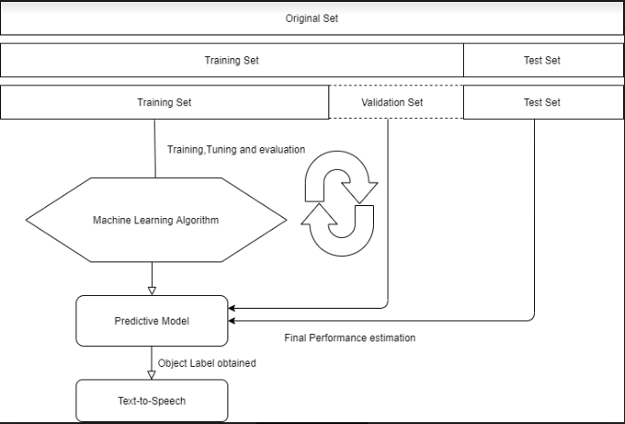

Fiure: Flow of the product

The product has the following modules:

1. Object Detection

For object detection, we created a large dataset consisting of all the common real-time objects with their respective labels. After creating the dataset we created a neural network model with the help of the algorithm that runs through a variation of an extremely complex Convolutional Neural Network architecture. The convolutional neural network is then trained using supervised learning method. Thus after training the neural network model, we have used webcam to test images in this trained model and it processes one frame at a time. Thus the model detects all the objects in the frame and label them accordingly.

1. Text-to-Speech

After the object has been detected and their respective label have been obtained, the label is used for obtaining voice assistant. For that we have send the text description to the Google Text-to-Speech using the **gTTS** package. Thus in this module we obtain a voice feedback for the objects that have the highest accuracy in the frame, for example :”Person is detected”.

**Technologies Used:**

* Machine learning
* IoT
* Deep Learning

**Platform Used:**

* Anaconda
* Arduino

**Get the model and code from this link**

<https://drive.google.com/open?id=1wTP9mmg9GDUc8B8780IhO2NKGza2S04c>

**Conclusion:**

The technologies like artificial intelligence, machine learning and internet of things plays a vital role in the development of the IT sector. We have made use of these technologies for the visually impaired people so that they too can lead a normal and independent life like other people. Our product will help the visually challenged to recognize the objects and surroundings. Object detection will help to recognize the surrounding objects. Text-to-speech will help as voice assistant.Thus, the project will be able to serve the visually challenged people with a beter assistant. Our product could be applied in multilingual application in the coming days so that a person will be able to use their application in their own language without any trouble. In addition, our proposed system can be deployed with the Google Maps.In future the proposed system will be able interpret the textual description in a much better way. The Image recognition can be enhanced with much more details about the image captured through the camera.